I&D Ocean Compliance Documentation

**Functional Documentation**

**Introduction:**

This documentation provides an overview of the I&D Ocean Dashboard development. It details the steps and locations for updating the relevant files.

**Uploading Source files for Power BI Reports**

This pathway guides you on where to upload the updated **Employee master** file.

**Pathway:** General>Data Sources for Power BI > Employee Master

**Step: 1**

Go to the **" Data Sources for Power BI"** folder to uploadthe latest file. 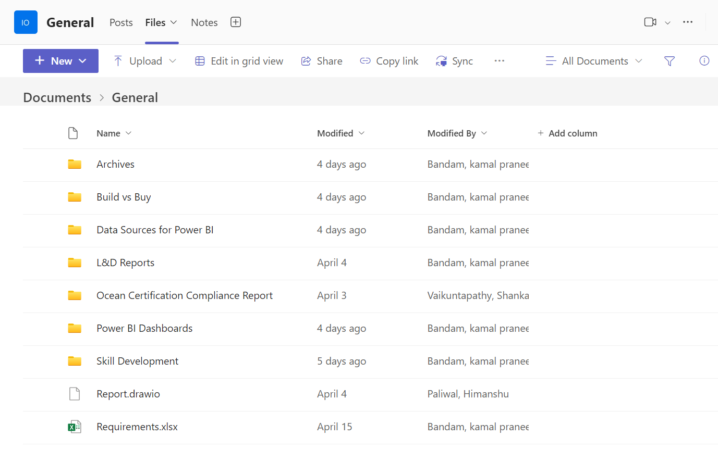

**Step: 2**

Within that, select the **"Employee Master"** folder to upload the updated source file on which we are going to work.

**This is where the source file needs to be updated.**

**Note: When updating the file in the Teams channel, please ensure that the file name follows the FORMAT shown above. Additionally, after opening the file, make sure the sheet name is the same as specified.**

**File Name: NewEmployeeMaster-DDMMMYYYY-HHMMam(or)pm**

**Sheet Name: NewEmployeeMaster**

**Step: 3**

To update the **data reports**, select the **"Ocean Consolidated Report"** folder.

This pathway guides you on where to upload the updated **Ocean Consolidated Report** file.

**Pathway:** General>Data Sources for Power BI > Ocean Consolidated Report

**This is where the source file needs to be updated.**

**Note: When updating the file in the Teams channel, please ensure that the file name follows the FORMAT shown above. Additionally, after opening the file, make sure the sheet name is the same as specified.**

**File Name: Consolidated Weighted Score Report_DD_MM_YY**

**Sheet Name: I&D**

**Step 4:**

[I&D OCEAN Compliance Dashboard - Power BI](https://app.powerbi.com/groups/cfd11332-098b-4728-9ca5-ceb6d59d26be/reports/2e5c73da-9e12-4ed5-9265-26d9b1322ab3/ReportSection3730a532200723995aef?experience=power-bi) when you click on the dashboard link, you can directly navigate to the power BI service where you can find the below I&D ocean compliance dashboard.

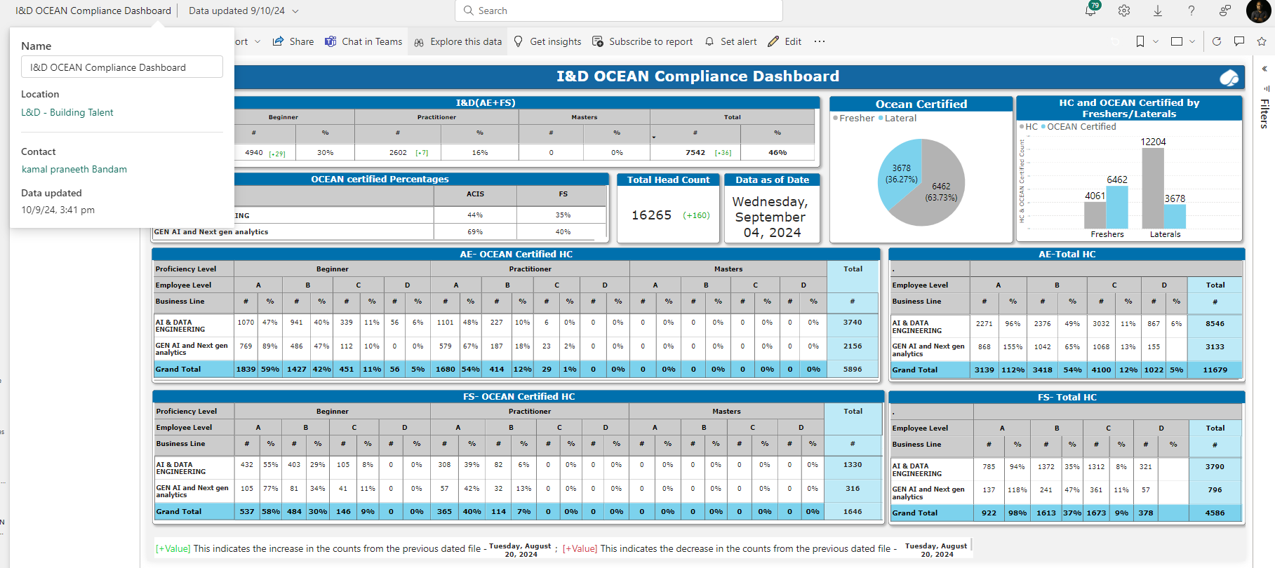

**Step 5:**

Based on the location mentioned above, the workspace for publishing the dashboard is

"L&D – Building Talent." When you click on it, you will be redirected to the page displayed below.

**Step 6:**

By using the search button as described in step 5, you can look for the I&D Ocean Compliance Dashboard.



**Step 7:**

When you click on the refresh button it will load the updated dashboard.

